CONTACT | COMPANY P.O. | QUOTED YES □ NO □
TEL # | FAX # | PRICE
DATE RECEIVED | DATE PROMISED | AUTHORIZED BY:
MFR | PH HZ SF | ENCL: TEFC ODP TENV EXP
FRAME | EFF DESIGN CODE | OTHER:
HP/KW | MODEL | ASSEMBLY: STD NON-STD
RPM | CATALOG | DUTY: CONT INT TIME _______
VOLTS | SERIAL | Winding:
AMPS | TYPE | Temp. Rise / Max. Amb.
DEPARTMENT----- LMR : SMR : | AC: 1PH : 3PH : DC : GEN : | PUMP: RAND: FORM OTHER

WINDING

CORE TEST COMPLETED BY:

QA _____
COMPLETE & ENCLOSE WORKSHEET | ACCEPTED REJECTED | REPAIRED YES NO

QA _____

WINDING INFORMATION COMPLETED BY:
AC | DATA | DC |  | DATA
SLOTS | TURNS / COIL | # OF SLOTS |  | # OF BARS
COILS / SLOT | PITCH 1- | COILS / SLOT |  | TURNS / COIL
GROUPS | WIRES IN MULT | WIRE SIZE |  | WIRES IN MULT
COILS / GROUP | WIRE SIZE | SLOT PITCH 1 - |  | COMM PITCH 1 -
LBS OF WIRE | CONNECTION | LBS OF WIRE
HEAD SIZE | DIST BT HEADS |  | TURNS | WIRE SIZE | POUNDS
CE EXTENSION | OPP EXTENSION | SHUNT
 |  | SERIES
LEAD LENGTH | # OF LEADS | INTERPOLE

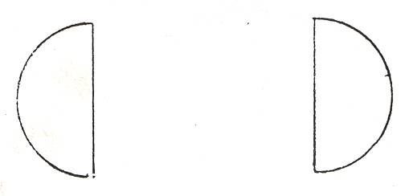

CORE SPECS
CORE LENGTH
CORE DIAMETER
BACK IRON
TOOTH WIDTH
SLOT DEPTH

QA _________

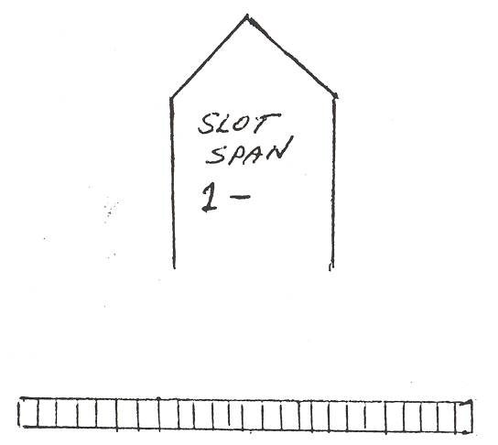

QA _____
TESTS COMPLETED BY:
SLOT

SPAN

1-__

AFTER REWIND
TEST | STATOR | ROTOR
MEGGER
HI-POT
SURGE
P. I.
RESISTANCE

