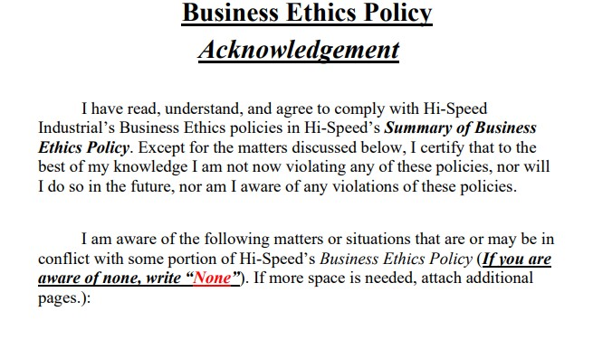

|  |  |
| --- | --- |
| **Employee Name:** | Tina Thompson |
| **Date:** | 04/29/2020 |
| **Employee Signature:** |  |

