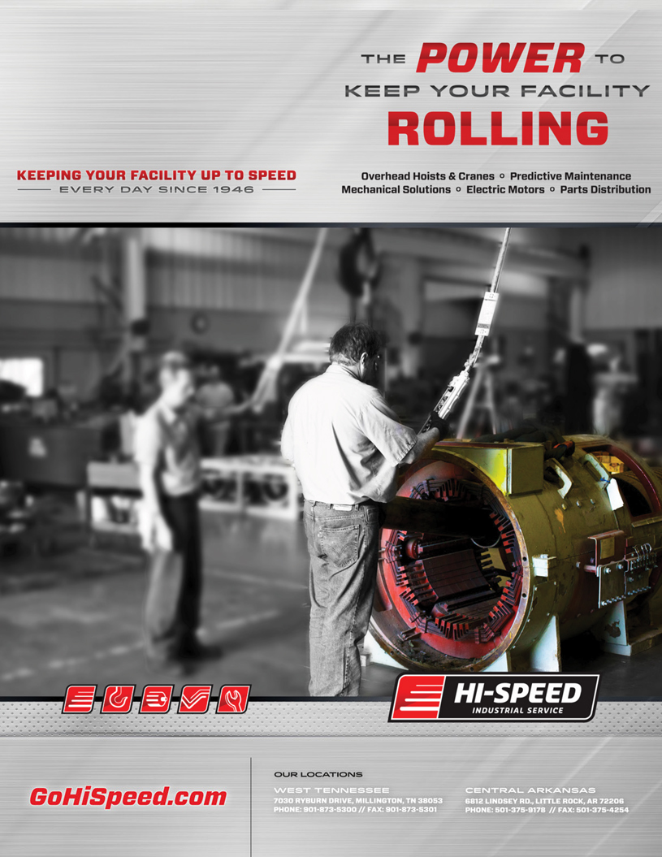

Date: 05/30/2019

IRG  
Account:  
Operation:  
Attention: Mitch  
Reference: Job#Test Radial Load  
  
Mitch,  
  
Upon completing a full evaluation on xx/yy/zz, the following was found:  
Winding single-phased (wye-connected)  
  
A single-phased winding failure is the result of an open in one phase of the power supply to the motor. The open is usually caused by a blown fuse, an open contactor, a broken power line or bad connections.  
  
  
Please find attached, all supporting documentation along images of discovery found during the teardown & inspection of this evaluation. Should you have any questions or require further assistance with this matter, please contact us.  
  
Our estimate for repair of the apparatus is attached as a supplementary document.  
  
Sincerely,

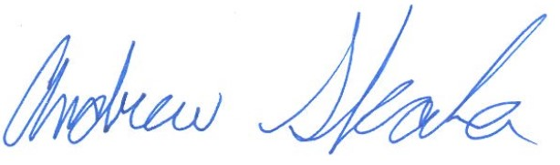

Andrew Skala  
Senior Motor Shop Coordinator & Electrical Engineer

