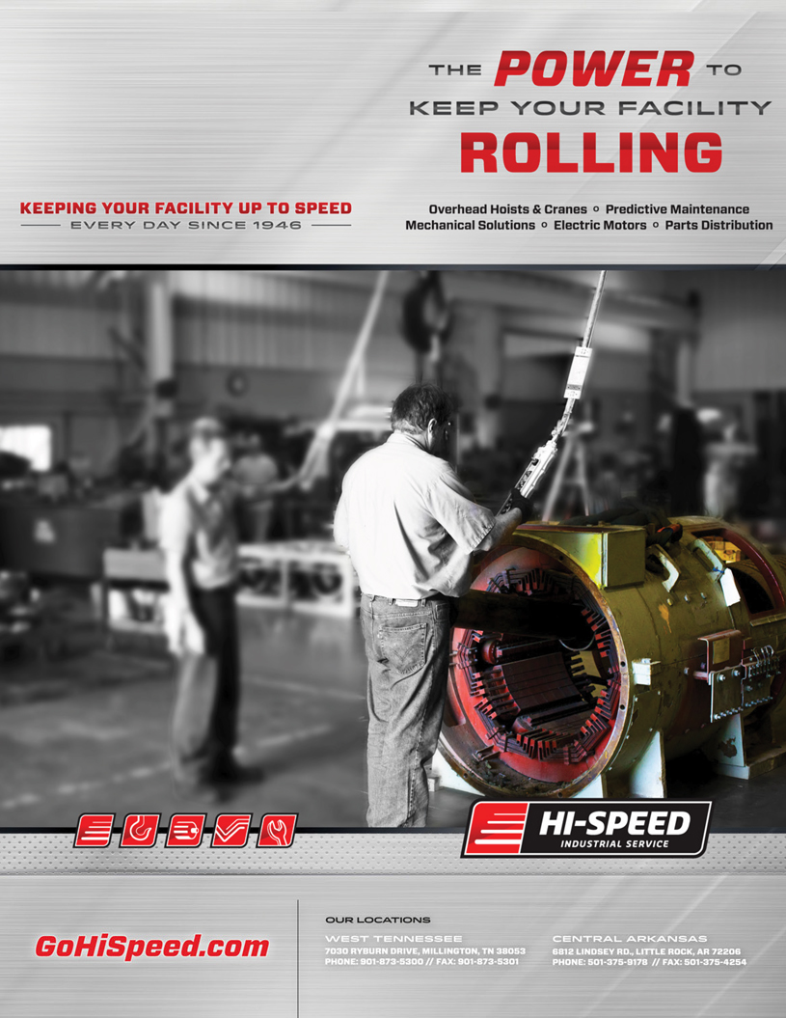

|  |  |
| --- | --- |
| Customer: Future Fuel | Date: 05/07/19 |
| PO#: | Job No: 95529 |

Dear ,

During the disassembly of the motor you provided to Hi-Speed Industrial Service, our technicians found

Below are a few of the comments provided by our technician:  
Bearings showed signs of possible frosting and brenaling and the ODE was overly greased causing grease to be on the windings. Recommend reconditioning

