Reopen RFQs
RFQs may be closed for various reasons: not enough information, customer won’t return calls, customer pushes the job to the next quarter or next year. It could be anything. Some of these RFQs get closed and just need the quick option to be reopened. That functionality has been implemented on the initial RFQ submitted activity with the following icon.
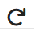

There are a couple of ways to track down RFQs as we have noted in RFQs Overview Tutorial. There are a couple options mentioned below.

Option 1
You can go to the activity screen and filter accordingly by “Closed RFQs”. You will need to then click on the view quote details to see if this RFQ is still closed. If it is still closed you can reopen from the RFQ Detail screen.

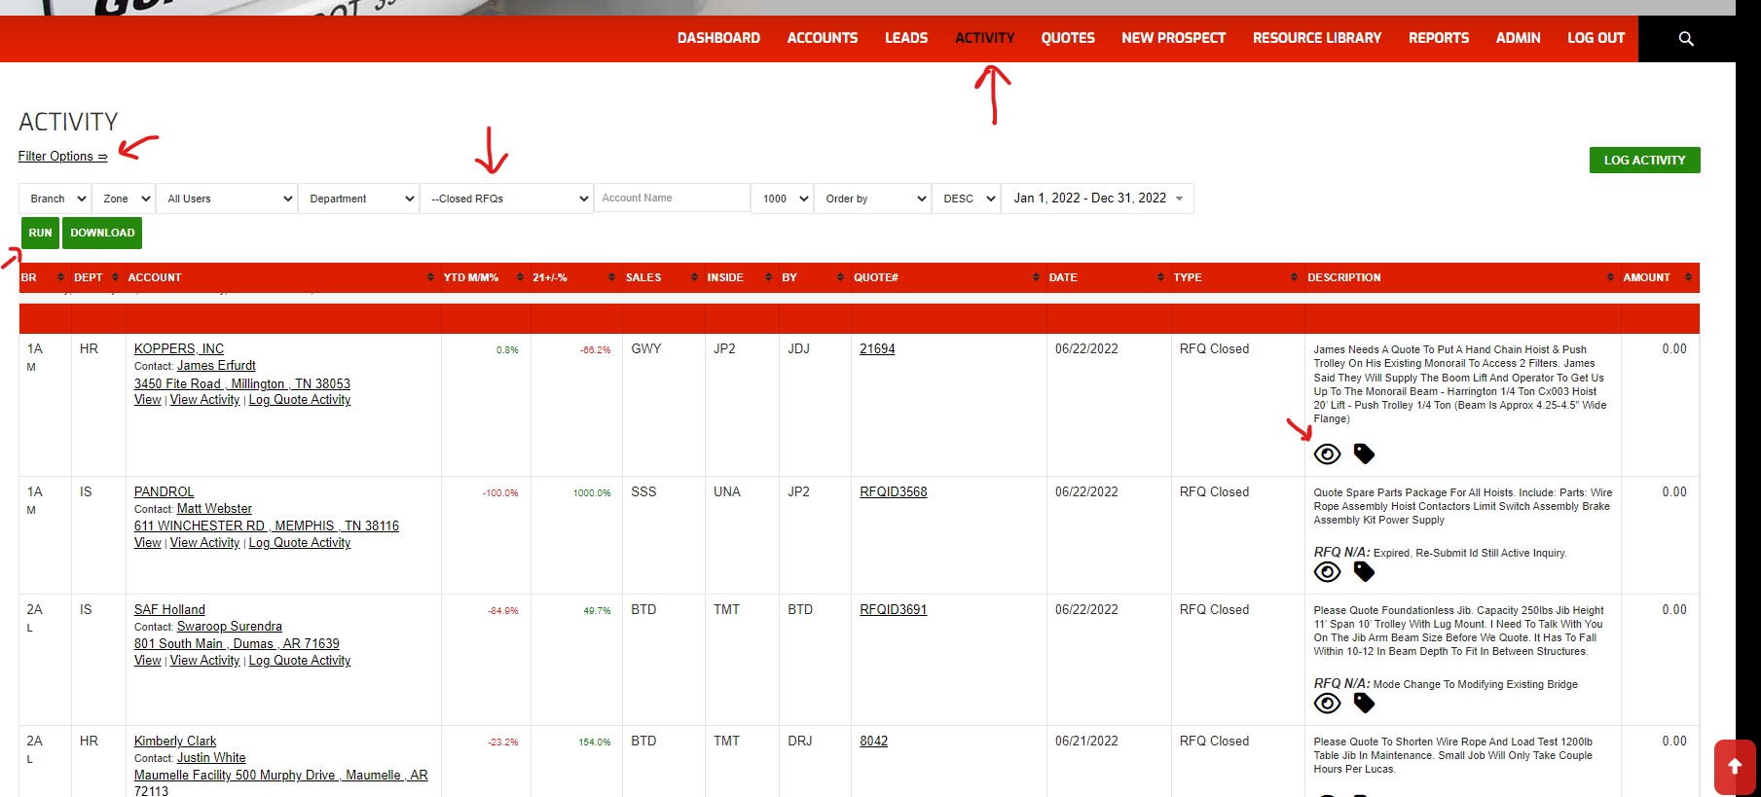

Option 2
You can go to account detail screen. There is now a new feature to show the RFQ archive for that account.
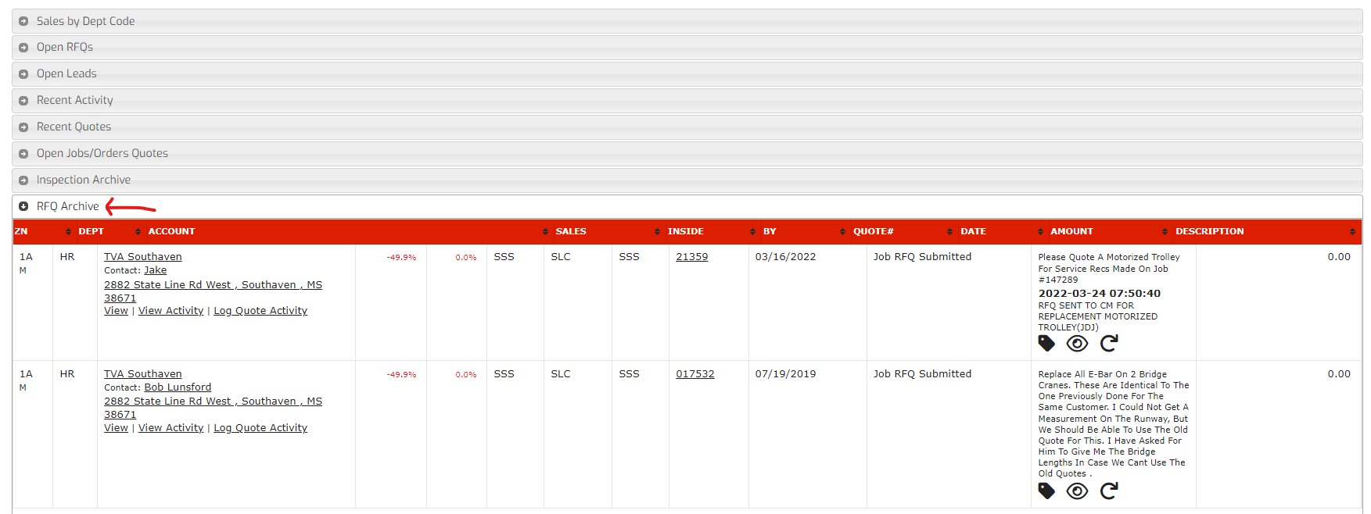

After clicking the Reopen Icon
You will see a popup box appear giving a couple of reasons that you are reopening the RFQ and a comment box to provide more information. An email should be sent after submitting the reopening of RFQ.
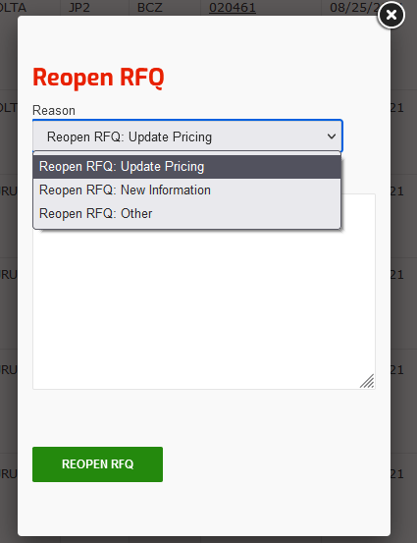

Open RFQs on Dashboard
Once the RFQ has been reopened, the RFQ will reappear on the dashboard with the reopen date.
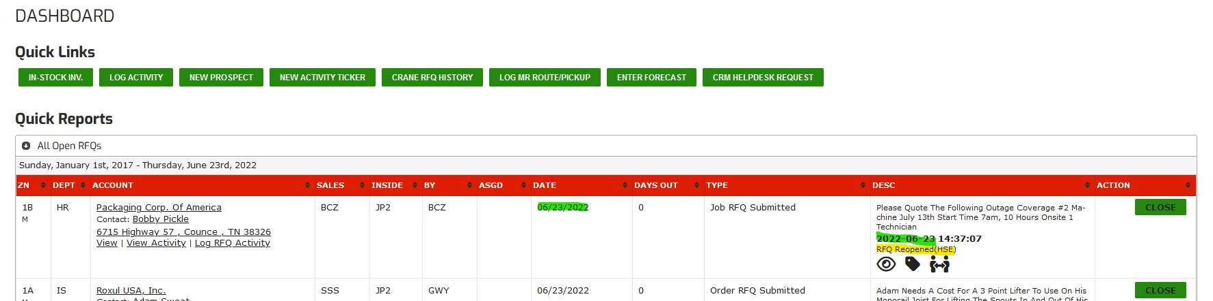

This RFQ Reopened status will not appear in the RFQ Submitted Call activity as a new RFQ Submitted however. Below is an example of how the Recent Activity from the RFQ Detail screen will show the progression of activity with this RFQ Reopened status.
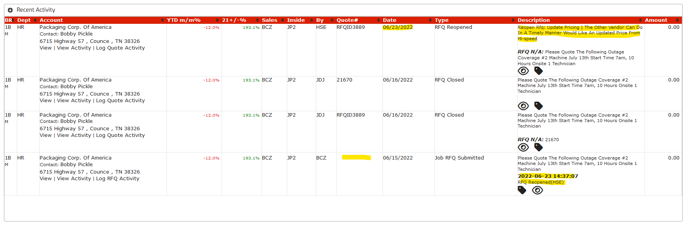

This has been tested in the development environment more extensively than in production, but if you see any issues, please click the “Submit Help Ticket” with details from your experience so we can improve this process.


