|  |  |  |  |
| --- | --- | --- | --- |
| **Customer:** | NCI GROUP INC | **Location/Desc:** | Lexington |
| **Address:** | 422 KIRBY DR | **Performed by:** | JR Going |
|  | Lexington,TN 38351 | **Date:** | 08/08/2025 |
| **Job/Order#** |  |  |  |

|  |  |  |  |
| --- | --- | --- | --- |
| **Motor Pickup:** | Picked up 1.3hp motor for inspection. **NOTES** | | |

|  |  |  |  |
| --- | --- | --- | --- |
| **Main Contact:** | Kenneth reeves | | |
| **Customer Signature:** |  | | |

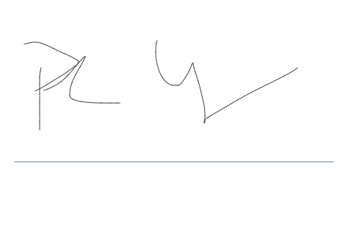

**NOTES**