|  |  |  |  |
| --- | --- | --- | --- |
| **Customer:** | SRG Global, Inc. | **Location/Desc:** | Newbern |
| **Address:** | 100 Fabrite Rd | **Performed by:** | JR Going |
|  | Newbern,TN 38059 | **Date:** | 08/06/2025 |
| **Job/Order#** |  |  |  |

|  |  |  |  |
| --- | --- | --- | --- |
| **Motor Pickup:** | Picked up fan for cleaning and balancing, quote new bearing replacement. **NOTES** | | |

|  |  |  |  |
| --- | --- | --- | --- |
| **Main Contact:** | scott thorpe | | |
| **Customer Signature:** |  | | |

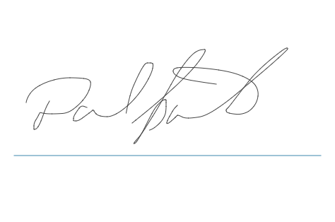

**NOTES**