|  |  |  |  |
| --- | --- | --- | --- |
| **Customer:** | Reynolds Metals Company | **Location/Desc:** | Malvern |
| **Address:** | 1333 Highway 270 | **Performed by:** | Lee Pettey |
|  | Malvern,AR 72104 | **Date:** | 08/05/2025 |
| **Job/Order#** |  |  |  |

|  |  |  |  |
| --- | --- | --- | --- |
| **Motor Pickup:** | Picked up a heat exchanger for a DC motor we previously fixed. **NOTES** | | |

|  |  |  |  |
| --- | --- | --- | --- |
| **Main Contact:** | Shoko Kremer | | |
| **Customer Signature:** |  | | |

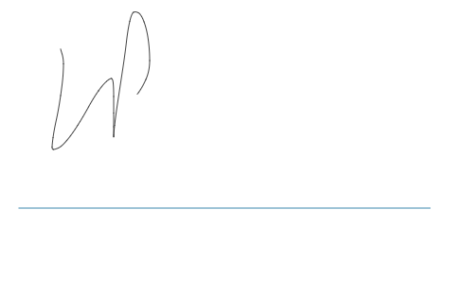

**NOTES**