|  |  |  |  |
| --- | --- | --- | --- |
| **Customer:** | Scepter, Inc. | **Location/Desc:** | Waverly |
| **Address:** | 1485 Scepter Lane | **Performed by:** | Terry Frazier |
|  | Waverly,TN 37185 | **Date:** | 08/01/2025 |
| **Job/Order#** | 156056 |  |  |

|  |  |  |  |
| --- | --- | --- | --- |
| **Motor Pickup:** | Dropped off 200hp picked up 250 hp **NOTES** | | |

|  |  |  |  |
| --- | --- | --- | --- |
| **Main Contact:** | Jacob Mcleod | | |
| **Customer Signature:** |  | | |

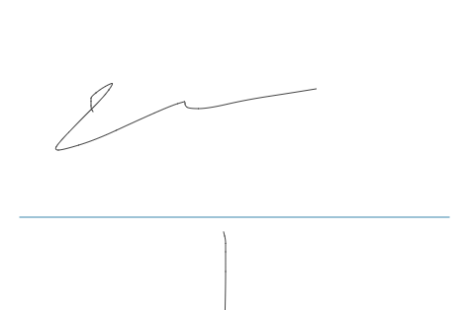

**NOTES**