|  |  |  |  |
| --- | --- | --- | --- |
| **Customer:** | Arcosa Marine Fiberglass Plant 1073 | **Location/Desc:** | Caruthersville |
| **Address:** | 2077 Co Rd 337 | **Performed by:** | Terry Frazier |
|  | Caruthersville,MO 63830 | **Date:** | 07/29/2025 |
| **Job/Order#** |  |  |  |

|  |  |  |  |
| --- | --- | --- | --- |
| **Reason for call:** |  | | |
| **Description of work:** |  | | |
| **Equipment and material used:** |  | | |
| **Recommended additional work:** |  | | |

|  |  |  |  |
| --- | --- | --- | --- |
| **Main Contact:** | Robert Womack | | |
| **Customer Signature:** |  | | |

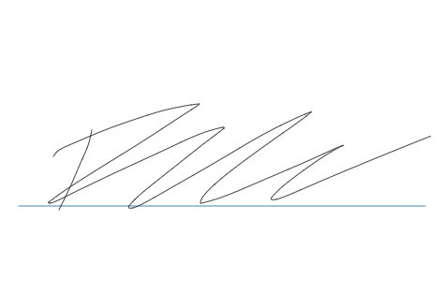

**NOTES**