|  |  |  |  |
| --- | --- | --- | --- |
| **Customer:** | SOUTHWESTERN ENERGY | **Location/Desc:** | Damascus |
| **Address:** | 1408 HWY 124 E | **Performed by:** | Lee Pettey |
|  | Damascus,AR 72039 | **Date:** | 07/23/2025 |
| **Job/Order#** |  |  |  |

|  |  |  |  |
| --- | --- | --- | --- |
| **Motor Pickup:** | Picked up two 125 hp motors for eval. I squot;m also going to make some RFQ squot;s to quote these new. **NOTES** | | |

|  |  |  |  |
| --- | --- | --- | --- |
| **Main Contact:** | Riley Conaway | | |
| **Customer Signature:** |  | | |

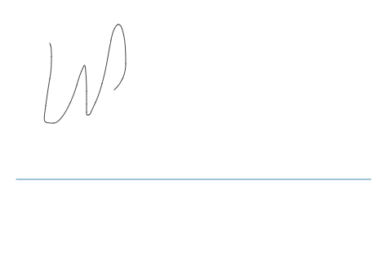

**NOTES**