|  |  |  |  |
| --- | --- | --- | --- |
| **Customer:** | Rich squot;s Products | **Location/Desc:** | Arlington |
| **Address:** | 5885 Jetway Drive | **Performed by:** | JR Going |
|  | Arlington,TN 38002 | **Date:** | 07/22/2025 |
| **Job/Order#** | 155798 |  |  |

|  |  |  |  |
| --- | --- | --- | --- |
| **Reason for call:** | Delivered 30 HP motor. | | |
| **Description of work:** |  | | |
| **Equipment and material used:** |  | | |
| **Recommended additional work:** |  | | |

|  |  |  |  |
| --- | --- | --- | --- |
| **Main Contact:** | Sean Dennis | | |
| **Customer Signature:** |  | | |

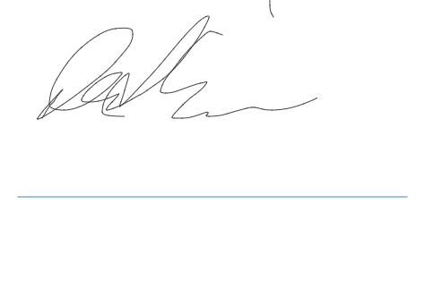

**NOTES**