|  |  |  |  |
| --- | --- | --- | --- |
| **Customer:** | KTG (USA) LP | **Location/Desc:** | Memphis |
| **Address:** | 400 Mahannah | **Performed by:** | JR Going |
|  | Memphis,TN 38107 | **Date:** | 07/21/2025 |
| **Job/Order#** |  |  |  |

|  |  |  |  |
| --- | --- | --- | --- |
| **Reason for call:** | Delivered 30 Horse from storage. | | |
| **Description of work:** |  | | |
| **Equipment and material used:** |  | | |
| **Recommended additional work:** |  | | |

|  |  |  |  |
| --- | --- | --- | --- |
| **Main Contact:** | Gary Davis | | |
| **Customer Signature:** |  | | |

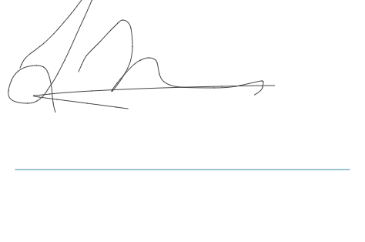

**NOTES**