|  |  |  |  |
| --- | --- | --- | --- |
| **Customer:** | Anchor Packaging | **Location/Desc:** | Paragould |
| **Address:** | 2211 N. 12th Ave. | **Performed by:** | JR Going |
|  | Paragould,AR 72450 | **Date:** | 06/23/2025 |
| **Job/Order#** | 154793 |  |  |

|  |  |  |  |
| --- | --- | --- | --- |
| **Reason for call:** | Delivered 350hp motor. | | |
| **Description of work:** |  | | |
| **Equipment and material used:** |  | | |
| **Recommended additional work:** |  | | |

|  |  |  |  |
| --- | --- | --- | --- |
| **Main Contact:** | Lael Breckenridge | | |
| **Customer Signature:** |  | | |

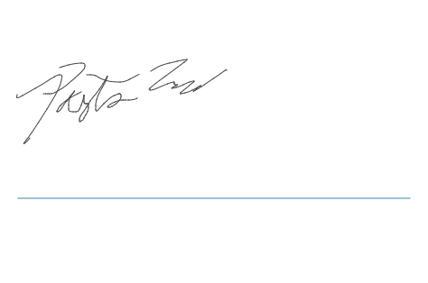

**NOTES**