|  |  |  |  |
| --- | --- | --- | --- |
| **Customer:** | Baxter Healthcare Corp. | **Location/Desc:** | Cleveland |
| **Address:** | Highway 61 North | **Performed by:** | JR Going |
|  | Cleveland,MS 38732 | **Date:** | 06/19/2025 |
| **Job/Order#** | 155752 |  |  |

|  |  |  |  |
| --- | --- | --- | --- |
| **Reason for call:** | Delivered 200 hp motor. | | |
| **Description of work:** |  | | |
| **Equipment and material used:** |  | | |
| **Recommended additional work:** |  | | |

|  |  |  |  |
| --- | --- | --- | --- |
| **Main Contact:** | MONTY BARBATI | | |
| **Customer Signature:** |  | | |

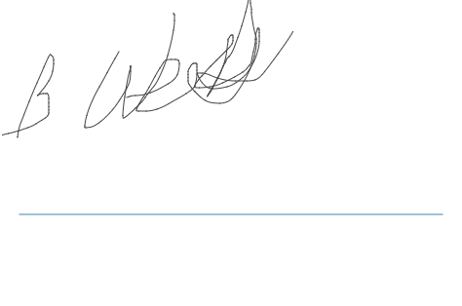

**NOTES**