|  |  |  |  |
| --- | --- | --- | --- |
| **Customer:** | Rich squot;s Products | **Location/Desc:** | Arlington |
| **Address:** | 5885 Jetway Drive | **Performed by:** | JR Going |
|  | Arlington,TN 38002 | **Date:** | 06/11/2025 |
| **Job/Order#** |  |  |  |

|  |  |  |  |
| --- | --- | --- | --- |
| **Motor Pickup:** | Picked up 30 HP motor. **NOTES** | | |

|  |  |  |  |
| --- | --- | --- | --- |
| **Main Contact:** |  | | |
| **Customer Signature:** |  | | |

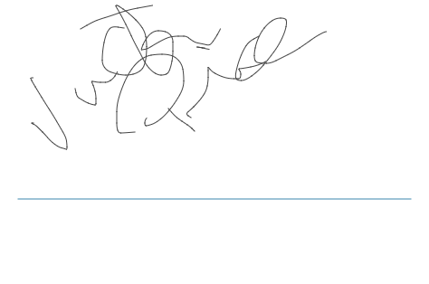

**NOTES**