|  |  |  |  |
| --- | --- | --- | --- |
| **Customer:** | COMMUNITY WATER SYSTEM | **Location/Desc:** | GREERS FERRY |
| **Address:** | 299 LAKESHORE DR | **Performed by:** | Lee Pettey |
|  | GREERS FERRY,AR 72067 | **Date:** | 05/27/2025 |
| **Job/Order#** | 0028422 |  |  |

|  |  |  |  |
| --- | --- | --- | --- |
| **Reason for call:** | delivered motor in crate and coupler. | | |
| **Description of work:** |  | | |
| **Equipment and material used:** |  | | |
| **Recommended additional work:** |  | | |

|  |  |  |  |
| --- | --- | --- | --- |
| **Main Contact:** |  | | |
| **Customer Signature:** |  | | |

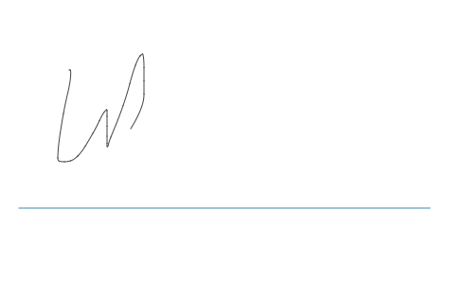

**NOTES**