|  |  |  |  |
| --- | --- | --- | --- |
| **Customer:** | SRG GLOBAL COATINGS LLC | **Location/Desc:** | NEWBERN |
| **Address:** | 100 FABRITE ROAD | **Performed by:** | JR Going |
|  | NEWBERN,TN 38059 | **Date:** | 05/07/2025 |
| **Job/Order#** |  |  |  |

|  |  |  |  |
| --- | --- | --- | --- |
| **Motor Pickup:** | Picked up 125 hp motor. **NOTES** | | |

|  |  |  |  |
| --- | --- | --- | --- |
| **Main Contact:** | Johnathan Waits | | |
| **Customer Signature:** |  | | |

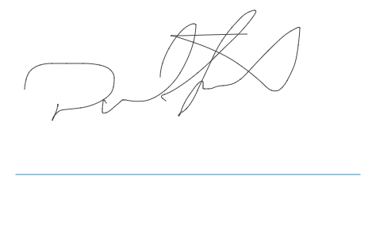

**NOTES**