|  |  |  |  |
| --- | --- | --- | --- |
| **Customer:** | AIR PRODUCTS & CHEMICAL | **Location/Desc:** | Oscela |
| **Address:** | 2027 E State Hwy 198 | **Performed by:** | JR Going |
|  | Oscela,AR 72370 | **Date:** | 04/30/2025 |
| **Job/Order#** |  |  |  |

|  |  |  |  |
| --- | --- | --- | --- |
| **Motor Pickup:** | Picked up pump **NOTES** | | |

|  |  |  |  |
| --- | --- | --- | --- |
| **Main Contact:** | Mark Medina | | |
| **Customer Signature:** |  | | |

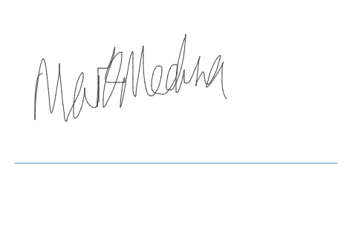

**NOTES**