|  |  |  |  |
| --- | --- | --- | --- |
| **Customer:** | Reynolds Metals Company | **Location/Desc:** | Malvern |
| **Address:** | 1333 Highway 270 | **Performed by:** | Lee Pettey |
|  | Malvern,AR 72104 | **Date:** | 04/29/2025 |
| **Job/Order#** | 103786 |  |  |

|  |  |  |  |
| --- | --- | --- | --- |
| **Reason for call:** | delivered 100hp motor | | |
| **Description of work:** |  | | |
| **Equipment and material used:** |  | | |
| **Recommended additional work:** |  | | |

|  |  |  |  |
| --- | --- | --- | --- |
| **Main Contact:** | Shaey Williams | | |
| **Customer Signature:** |  | | |

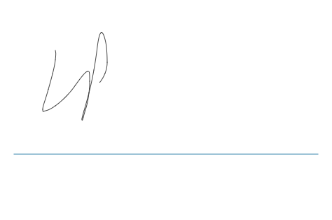

**NOTES**