|  |  |  |  |
| --- | --- | --- | --- |
| **Customer:** | NEW MILLENNIUM | **Location/Desc:** | Memphis |
| **Address:** | 4900 Hungerford Rd. | **Performed by:** | JR Going |
|  | Memphis,TN 38118 | **Date:** | 04/24/2025 |
| **Job/Order#** |  |  |  |

|  |  |  |  |
| --- | --- | --- | --- |
| **Motor Pickup:** | Picked up 2 hp motor. **NOTES** | | |

|  |  |  |  |
| --- | --- | --- | --- |
| **Main Contact:** | William Martin | | |
| **Customer Signature:** |  | | |

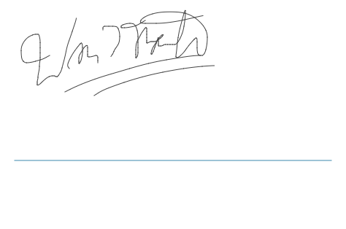

**NOTES**