|  |  |  |  |
| --- | --- | --- | --- |
| **Customer:** | KTG (USA) LP | **Location/Desc:** | Memphis |
| **Address:** | 400 Mahannah | **Performed by:** | JR Going |
|  | Memphis,TN 38107 | **Date:** | 04/10/2025 |
| **Job/Order#** |  |  |  |

|  |  |  |  |
| --- | --- | --- | --- |
| **Motor Pickup:** | Picked up three 50 hp motors and a 40 hp motor **NOTES** | | |

|  |  |  |  |
| --- | --- | --- | --- |
| **Main Contact:** | Gary Davis | | |
| **Customer Signature:** |  | | |

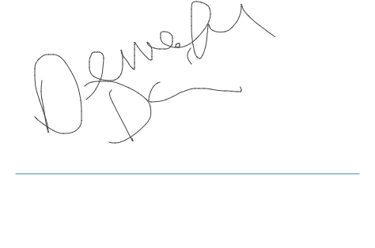

**NOTES**