|  |  |  |  |
| --- | --- | --- | --- |
| **Customer:** | MARS Food US | **Location/Desc:** | Greenville |
| **Address:** | 1098 N. Broadway | **Performed by:** | JR Going |
|  | Greenville,MS 38701 | **Date:** | 04/08/2025 |
| **Job/Order#** |  |  |  |

|  |  |  |  |
| --- | --- | --- | --- |
| **Motor Pickup:** | Picked up 11kw **NOTES** | | |

|  |  |  |  |
| --- | --- | --- | --- |
| **Main Contact:** | Rob Koestler | | |
| **Customer Signature:** |  | | |

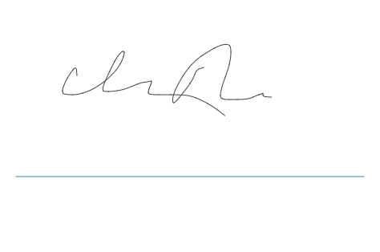

**NOTES**