|  |  |  |  |
| --- | --- | --- | --- |
| **Customer:** | Bryce Corporation | **Location/Desc:** | Searcy |
| **Address:** | 450 S. Benton St. | **Performed by:** | Lee Pettey |
|  | Searcy,AR 72143 | **Date:** | 04/02/2025 |
| **Job/Order#** | 0028192 |  |  |

|  |  |  |  |
| --- | --- | --- | --- |
| **Reason for call:** | delivered 3 new 1hp motors | | |
| **Description of work:** |  | | |
| **Equipment and material used:** |  | | |
| **Recommended additional work:** |  | | |

|  |  |  |  |
| --- | --- | --- | --- |
| **Main Contact:** | Braden Emerson | | |
| **Customer Signature:** |  | | |

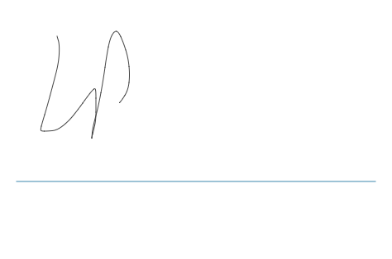

**NOTES**