|  |  |  |  |
| --- | --- | --- | --- |
| **Customer:** | Nucor-Yamato Steel Co. | **Location/Desc:** | Blytheville |
| **Address:** | 5929 E State Hwy 18 | **Performed by:** | JR Going |
|  | Blytheville,AR 72315 | **Date:** | 04/01/2025 |
| **Job/Order#** |  |  |  |

|  |  |  |  |
| --- | --- | --- | --- |
| **Motor Pickup:** | Picked up motor. **NOTES** | | |

|  |  |  |  |
| --- | --- | --- | --- |
| **Main Contact:** | Sunny Osagie | | |
| **Customer Signature:** |  | | |

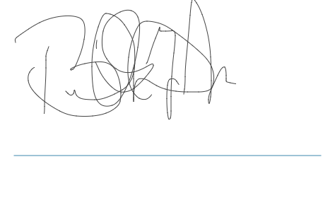

**NOTES**