|  |  |  |  |
| --- | --- | --- | --- |
| **Customer:** | REMURIATE LLC | **Location/Desc:** | OSCEOLA |
| **Address:** | 2044 EAST COUNTY RD 876 | **Performed by:** | JR Going |
|  | OSCEOLA,AR 72370 | **Date:** | 03/17/2025 |
| **Job/Order#** | 154776 |  |  |

|  |  |  |  |
| --- | --- | --- | --- |
| **Reason for call:** | Delivered 500 hp motor. | | |
| **Description of work:** |  | | |
| **Equipment and material used:** |  | | |
| **Recommended additional work:** |  | | |

|  |  |  |  |
| --- | --- | --- | --- |
| **Main Contact:** | Sonny Phipps | | |
| **Customer Signature:** |  | | |

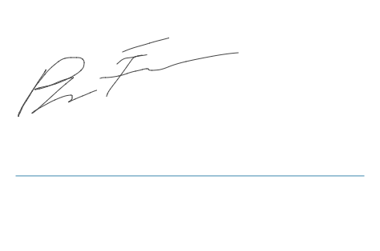

**NOTES**