|  |  |  |  |
| --- | --- | --- | --- |
| **Customer:** | Tetra Technologies | **Location/Desc:** | West Memphis |
| **Address:** | 2201 Port Road | **Performed by:** | JR Going |
|  | West Memphis,AR 72301 | **Date:** | 03/14/2025 |
| **Job/Order#** |  |  |  |

|  |  |  |  |
| --- | --- | --- | --- |
| **Reason for call:** | Delivered 20 hp motor for inside sales | | |
| **Description of work:** |  | | |
| **Equipment and material used:** |  | | |
| **Recommended additional work:** |  | | |

|  |  |  |  |
| --- | --- | --- | --- |
| **Main Contact:** | Craig Lindsey | | |
| **Customer Signature:** |  | | |

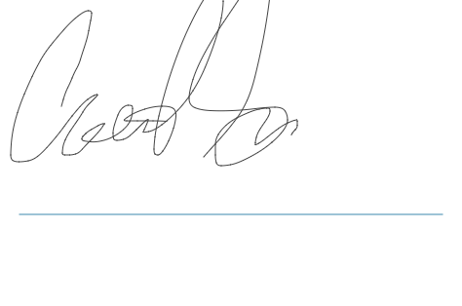

**NOTES**