|  |  |  |  |
| --- | --- | --- | --- |
| **Customer:** | Kiswire Pine Bluff, Inc. | **Location/Desc:** | White Hall |
| **Address:** | 5100 Industrial Dr. S. | **Performed by:** | Lee Pettey |
|  | White Hall,AR 71602 | **Date:** | 03/13/2025 |
| **Job/Order#** |  |  |  |

|  |  |  |  |
| --- | --- | --- | --- |
| **Motor Pickup:** | I picked up a fan assembly for eval. I had a great visit with Steve and Jackie. Made sure they had the correct email address to send all the PO numbers. I got a PO number for a fan balance job. Made sure they had the copy of another job invoice it has to get a higher approval and we should get that soon **NOTES** | | |

|  |  |  |  |
| --- | --- | --- | --- |
| **Main Contact:** | Steve Keese | | |
| **Customer Signature:** |  | | |

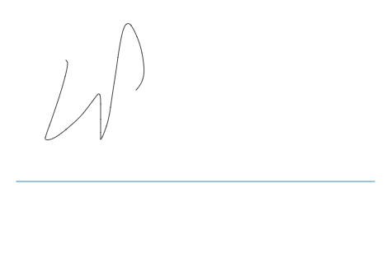

**NOTES**