|  |  |  |  |
| --- | --- | --- | --- |
| **Customer:** | GREENBRIER-MARMADUKE | **Location/Desc:** | MARMADUKE |
| **Address:** | 7755 HIGHWAY 34 E | **Performed by:** |  |
|  | MARMADUKE,AR 72443-950 | **Date:** | 03/06/2025 |
| **Job/Order#** | 153860 |  |  |

|  |  |  |  |
| --- | --- | --- | --- |
| **Reason for call:** | Delivered magnet. | | |
| **Description of work:** |  | | |
| **Equipment and material used:** |  | | |
| **Recommended additional work:** |  | | |

|  |  |  |  |
| --- | --- | --- | --- |
| **Main Contact:** | Flynn Willis | | |
| **Customer Signature:** |  | | |

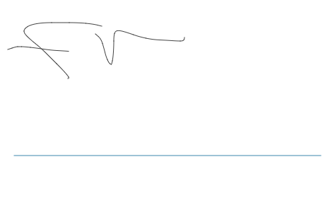

**NOTES**