|  |  |  |  |
| --- | --- | --- | --- |
| **Customer:** | SLOAN VALVE CO-ARK DIVISION | **Location/Desc:** | Augusta |
| **Address:** | 2719 Business Highway 33 | **Performed by:** | Lee Pettey |
|  | Augusta,AR 72006 | **Date:** | 02/28/2025 |
| **Job/Order#** |  |  |  |

|  |  |  |  |
| --- | --- | --- | --- |
| **Motor Pickup:** | Picked up two gear boxes for rush repair. One needs to be modified and the other one needs to be rebuilt they need one back ASAP. **NOTES** | | |

|  |  |  |  |
| --- | --- | --- | --- |
| **Main Contact:** | Joshua Jenkins | | |
| **Customer Signature:** |  | | |

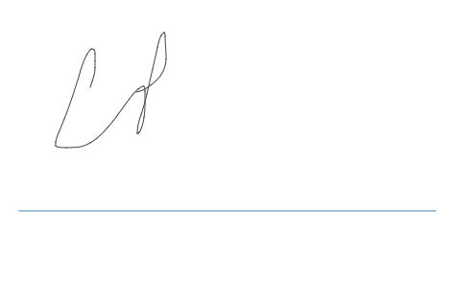

**NOTES**