|  |  |  |  |
| --- | --- | --- | --- |
| **Customer:** | PACIFIC MFG TN INC | **Location/Desc:** | Jackson |
| **Address:** | 555 Smith Lane | **Performed by:** | JR Going |
|  | Jackson,TN 38301 | **Date:** | 02/27/2025 |
| **Job/Order#** | 154378 |  |  |

|  |  |  |  |
| --- | --- | --- | --- |
| **Reason for call:** | Delivered 15 hp motor. | | |
| **Description of work:** |  | | |
| **Equipment and material used:** |  | | |
| **Recommended additional work:** |  | | |

|  |  |  |  |
| --- | --- | --- | --- |
| **Main Contact:** | Rick Fowler | | |
| **Customer Signature:** |  | | |

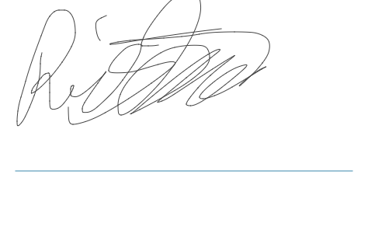

**NOTES**