|  |  |  |  |
| --- | --- | --- | --- |
| **Customer:** | ARKANSAS INDUSTRIAL MACHINERY | **Location/Desc:** | North Little Rock |
| **Address:** | 3804 N. Nona Street | **Performed by:** | Lee Pettey |
|  | North Little Rock,AR 72118 | **Date:** | 02/21/2025 |
| **Job/Order#** | 104161 |  |  |

|  |  |  |  |
| --- | --- | --- | --- |
| **Reason for call:** | delivered stator | | |
| **Description of work:** |  | | |
| **Equipment and material used:** |  | | |
| **Recommended additional work:** |  | | |

|  |  |  |  |
| --- | --- | --- | --- |
| **Main Contact:** |  | | |
| **Customer Signature:** |  | | |

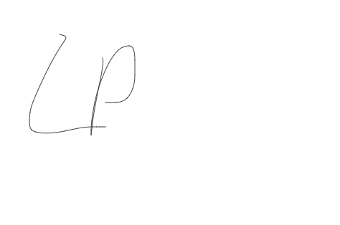

**NOTES**