|  |  |  |  |
| --- | --- | --- | --- |
| **Customer:** | TVA JOHNSONVILLE COMBUST TURB | **Location/Desc:** | NEW JOHNSONVILLE |
| **Address:** | 535 STEAM PLANT RD | **Performed by:** | Joseph Shurtz |
|  | NEW JOHNSONVILLE,TN 37134 | **Date:** | 02/10/2025 |
| **Job/Order#** |  |  |  |

|  |  |  |  |
| --- | --- | --- | --- |
| **Reason for call:** | Delivered job numbers 154452 and 154451 | | |
| **Description of work:** |  | | |
| **Equipment and material used:** |  | | |
| **Recommended additional work:** |  | | |

|  |  |  |  |
| --- | --- | --- | --- |
| **Main Contact:** | Rob Harris | | |
| **Customer Signature:** |  | | |

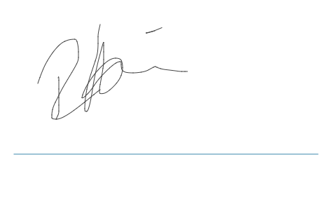

**NOTES**