|  |  |  |  |
| --- | --- | --- | --- |
| **Customer:** | Holcim Solutions and Products | **Location/Desc:** | Prescott |
| **Address:** | 1406 Hwy 371 North | **Performed by:** | Lee Pettey |
|  | Prescott,AR 71857 | **Date:** | 02/04/2025 |
| **Job/Order#** | 103764 |  |  |

|  |  |  |  |
| --- | --- | --- | --- |
| **Reason for call:** | delivered fan and shaft | | |
| **Description of work:** |  | | |
| **Equipment and material used:** |  | | |
| **Recommended additional work:** |  | | |

|  |  |  |  |
| --- | --- | --- | --- |
| **Main Contact:** |  | | |
| **Customer Signature:** |  | | |

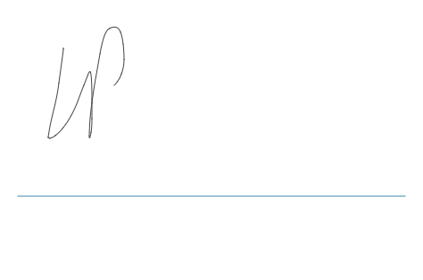

**NOTES**