|  |  |  |  |
| --- | --- | --- | --- |
| **Customer:** | MOUNTAIN VIEW WATER PLANT | **Location/Desc:** | Mountain View |
| **Address:** | 571 Ruddles Rd. | **Performed by:** | Lee Pettey |
|  | Mountain View,AR 72560 | **Date:** | 01/29/2025 |
| **Job/Order#** |  |  |  |

|  |  |  |  |
| --- | --- | --- | --- |
| **Reason for call:** | delivered small pump 103167 | | |
| **Description of work:** |  | | |
| **Equipment and material used:** |  | | |
| **Recommended additional work:** |  | | |

|  |  |  |  |
| --- | --- | --- | --- |
| **Main Contact:** | Jesse Dandridge | | |
| **Customer Signature:** |  | | |

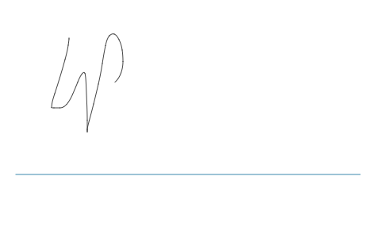

**NOTES**