|  |  |  |  |
| --- | --- | --- | --- |
| **Customer:** | WABTEC COMPONENTS LLC | **Location/Desc:** | Lexington |
| **Address:** | Hwy 22 N. | **Performed by:** | JR Going |
|  | Lexington,TN 38351 | **Date:** | 01/22/2025 |
| **Job/Order#** | 153965 |  |  |

|  |  |  |  |
| --- | --- | --- | --- |
| **Reason for call:** | delivered hoist to 200 smith lane Jackson TN. | | |
| **Description of work:** |  | | |
| **Equipment and material used:** |  | | |
| **Recommended additional work:** |  | | |

|  |  |  |  |
| --- | --- | --- | --- |
| **Main Contact:** | David Freeman | | |
| **Customer Signature:** |  | | |

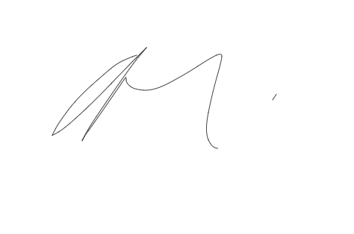

**NOTES**