|  |  |  |  |
| --- | --- | --- | --- |
| **Customer:** | Certainteed Corporation | **Location/Desc:** | Glenwood |
| **Address:** | RP Glenwood, AR | **Performed by:** | Lee Pettey |
|  | Glenwood,AR 71943 | **Date:** | 01/21/2025 |
| **Job/Order#** |  |  |  |

|  |  |  |  |
| --- | --- | --- | --- |
| **Motor Pickup:** | Picked up a motor for eval. **NOTES** | | |

|  |  |  |  |
| --- | --- | --- | --- |
| **Main Contact:** | Ron Hutson | | |
| **Customer Signature:** |  | | |

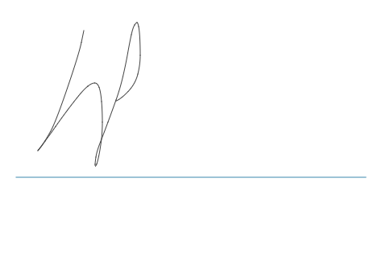

**NOTES**