|  |  |  |  |
| --- | --- | --- | --- |
| **Customer:** | UNIPRES SOUTHEAST USA INC | **Location/Desc:** | FOREST |
| **Address:** | 1001 FOUNTAIN DR | **Performed by:** | JR Going |
|  | FOREST,MS 38074 | **Date:** | 01/14/2025 |
| **Job/Order#** |  |  |  |

|  |  |  |  |
| --- | --- | --- | --- |
| **Motor Pickup:** | Picked up 100 HP motor. **NOTES** | | |

|  |  |  |  |
| --- | --- | --- | --- |
| **Main Contact:** | Mason Shelley | | |
| **Customer Signature:** |  | | |

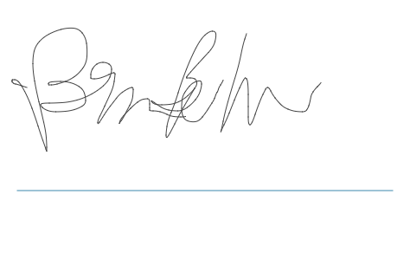

**NOTES**