|  |  |  |  |
| --- | --- | --- | --- |
| **Customer:** | Tyson Foods, Inc. | **Location/Desc:** | Clarksville |
| **Address:** | 301 East Cherry Street | **Performed by:** | Lee Pettey |
|  | Clarksville,AR 72830 | **Date:** | 01/13/2025 |
| **Job/Order#** | 103516 |  |  |

|  |  |  |  |
| --- | --- | --- | --- |
| **Reason for call:** | delivered small pump | | |
| **Description of work:** |  | | |
| **Equipment and material used:** |  | | |
| **Recommended additional work:** |  | | |

|  |  |  |  |
| --- | --- | --- | --- |
| **Main Contact:** | Tommy Steele | | |
| **Customer Signature:** |  | | |

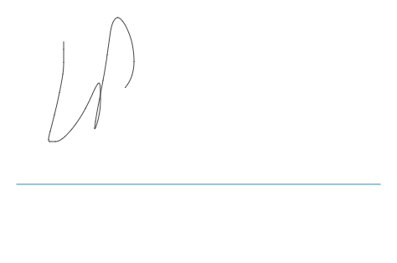

**NOTES**