|  |  |  |  |
| --- | --- | --- | --- |
| **Customer:** | Hi-Speed, Inc. | **Location/Desc:** | Little Rock |
| **Address:** | 6812 Lindsey Road | **Performed by:** | JR Going |
|  | Little Rock,AR 72206 | **Date:** | 01/09/2025 |
| **Job/Order#** |  |  |  |

|  |  |  |  |
| --- | --- | --- | --- |
| **Motor Pickup:** | Picked up 2 motor blower combos. And 2 rotors **NOTES** | | |

|  |  |  |  |
| --- | --- | --- | --- |
| **Main Contact:** | David Williams | | |
| **Customer Signature:** |  | | |

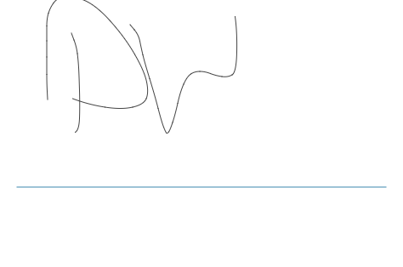

**NOTES**