|  |  |  |  |
| --- | --- | --- | --- |
| **Customer:** | STILES WASTEWATER TREATMENT | **Location/Desc:** | MEMPHIS |
| **Address:** | FACILITY | **Performed by:** | JR Going |
|  | MEMPHIS,TN 38127 | **Date:** | 01/08/2025 |
| **Job/Order#** |  |  |  |

|  |  |  |  |
| --- | --- | --- | --- |
| **Reason for call:** | delivered rotor and exciter to be worked on. | | |
| **Description of work:** |  | | |
| **Equipment and material used:** |  | | |
| **Recommended additional work:** |  | | |

|  |  |  |  |
| --- | --- | --- | --- |
| **Main Contact:** | Don Hudgins | | |
| **Customer Signature:** |  | | |

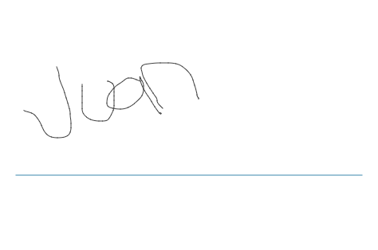

**NOTES**