|  |  |  |  |
| --- | --- | --- | --- |
| **Customer:** | SAINT JEAN INDUSTRIES, INC. | **Location/Desc:** | Heber Springs |
| **Address:** | 424 Industrial Park Rd | **Performed by:** | Lee Pettey |
|  | Heber Springs,AR 72543 | **Date:** | 12/31/2024 |
| **Job/Order#** |  |  |  |

|  |  |  |  |
| --- | --- | --- | --- |
| **Motor Pickup:** | Picked up fan unit for eval. Scheduled to pick up another fan unit Thursday morning **NOTES** | | |

|  |  |  |  |
| --- | --- | --- | --- |
| **Main Contact:** | Sammy Settlemire | | |
| **Customer Signature:** |  | | |

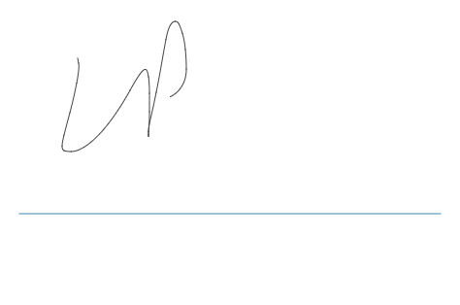

**NOTES**