|  |  |  |  |
| --- | --- | --- | --- |
| **Customer:** | PECO FOODS | **Location/Desc:** | POCAHONTAS |
| **Address:** | 4114 HWY 67 SOUTH | **Performed by:** | JR Going |
|  | POCAHONTAS,AR 72455 | **Date:** | 12/20/2024 |
| **Job/Order#** | 154228 |  |  |

|  |  |  |  |
| --- | --- | --- | --- |
| **Reason for call:** | Delivered 150 HP motor. | | |
| **Description of work:** |  | | |
| **Equipment and material used:** |  | | |
| **Recommended additional work:** |  | | |

|  |  |  |  |
| --- | --- | --- | --- |
| **Main Contact:** | Irving Hughes | | |
| **Customer Signature:** |  | | |

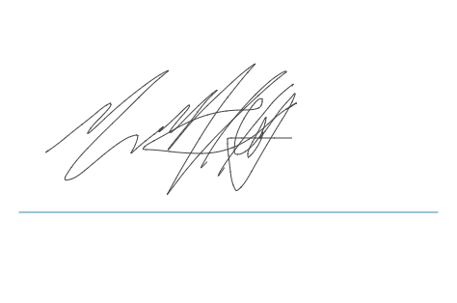

**NOTES**