|  |  |  |  |
| --- | --- | --- | --- |
| **Customer:** | Mid-South Conveying | **Location/Desc:** | Collierville |
| **Address:** | 170 Mid-South Cove | **Performed by:** | JR Going |
|  | Collierville,TN 38017 | **Date:** | 11/12/2024 |
| **Job/Order#** |  |  |  |

|  |  |  |  |
| --- | --- | --- | --- |
| **Motor Pickup:** | Picked up 50 HP motor. **NOTES** | | |

|  |  |  |  |
| --- | --- | --- | --- |
| **Main Contact:** |  | | |
| **Customer Signature:** |  | | |

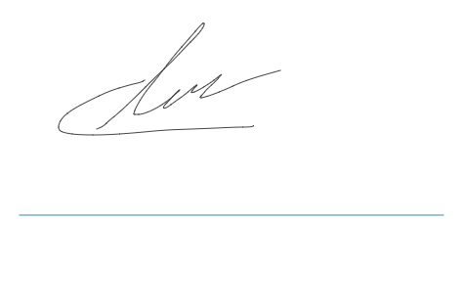

**NOTES**