|  |  |  |  |
| --- | --- | --- | --- |
| **Customer:** | BLAKE & PENDLETON | **Location/Desc:** | BARTLETT |
| **Address:** | 3144 STAGE POST DR | **Performed by:** | Kevin W Maxwell |
|  | BARTLETT,TN 38133 | **Date:** | 06/12/2024 |
| **Job/Order#** |  |  |  |

|  |  |  |  |
| --- | --- | --- | --- |
| **Reason for call:** | Shaft laser alignment at MS Silicone in Burnsville, MS | | |
| **Description of work:** | Performed Shaft laser alignment at MS Silicone in Burnsville, MS Aligned Air Comp 2 within spec for coupling and rpm. | | |
| **Equipment and material used:** |  | | |
| **Recommended additional work:** |  | | |

|  |  |  |  |
| --- | --- | --- | --- |
| **Main Contact:** | Jay Giannini | | |
| **Customer Signature:** |  | | |

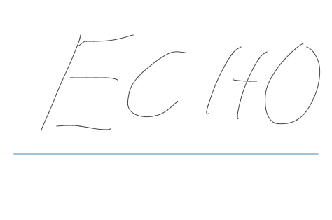

**NOTES**