|  |  |  |  |
| --- | --- | --- | --- |
| **Customer:** | MEMPHIS CELLULOSE LLC | **Location/Desc:** | MEMPHIS |
| **Address:** | 920 SCOTT ST | **Performed by:** | Joseph Shurtz |
|  | MEMPHIS,TN 38112 | **Date:** | 02/14/2024 |
| **Job/Order#** |  |  |  |

|  |  |  |  |
| --- | --- | --- | --- |
| **Reason for call:** | Balance four fans | | |
| **Description of work:** | Balance the south accepts fan,the shapes fan, trim fan and supply fan | | |
| **Equipment and material used:** |  | | |
| **Recommended additional work:** |  | | |

|  |  |  |  |
| --- | --- | --- | --- |
| **Main Contact:** |  | | |
| **Customer Signature:** |  | | |

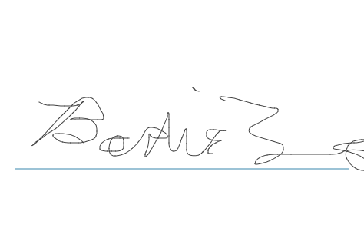

**NOTES**