|  |  |  |  |
| --- | --- | --- | --- |
| **Customer:** | MISSISSIPPI SILICON, LLC | **Location/Desc:** | Burnsville |
| **Address:** | 80 County Road 210 | **Performed by:** | Brandon Sullins |
|  | Burnsville ,MS 38833 | **Date:** | 07/24/2023 |
| **Job/Order#** | 149964 |  |  |

|  |  |  |  |
| --- | --- | --- | --- |
| **Reason for call:** | Describe what was delivered. | | |
| **Description of work:** |  | | |
| **Equipment and material used:** |  | | |
| **Recommended additional work:** |  | | |

|  |  |  |  |
| --- | --- | --- | --- |
| **Main Contact:** | Idk Idk | | |
| **Customer Signature:** |  | | |

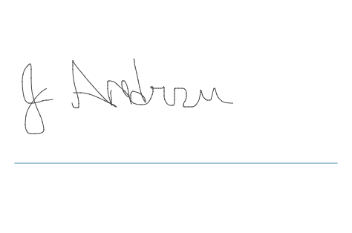

**NOTES**