|  |  |  |  |
| --- | --- | --- | --- |
| **Customer:** | New Way Truck | **Location/Desc:** | Booneville |
| **Address:** | 1 Wolverine Drive | **Performed by:** | JR Going |
|  | Booneville,MS 38829 | **Date:** | 12/18/2024 |
| **Job/Order#** |  |  |  |

|  |  |  |  |
| --- | --- | --- | --- |
| **Motor Pickup:** | Met with Keith Hamm and picked up two 20 HP motors. **NOTES** | | |

|  |  |  |  |
| --- | --- | --- | --- |
| **Main Contact:** | Jessie Kyle | | |
| **Customer Signature:** |  | | |

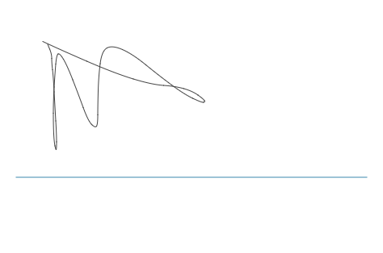

**NOTES**