|  |  |  |  |
| --- | --- | --- | --- |
| **Customer:** | Delta Plastics of the South | **Location/Desc:** | Stuttgart |
| **Address:** | 3104 So. Main | **Performed by:** | Lee Pettey |
|  | Stuttgart,AR 72160 | **Date:** | 12/18/2024 |
| **Job/Order#** |  |  |  |

|  |  |  |  |
| --- | --- | --- | --- |
| **Motor Pickup:** | Picked up large motor for eval **NOTES** | | |

|  |  |  |  |
| --- | --- | --- | --- |
| **Main Contact:** | brian winkelpleck | | |
| **Customer Signature:** |  | | |

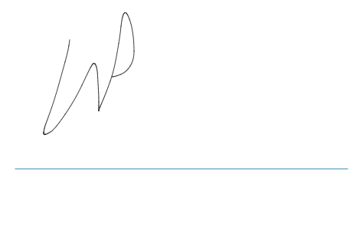

**NOTES**