|  |  |  |  |
| --- | --- | --- | --- |
| **Customer:** | 19TH AMXS | **Location/Desc:** | LRAFB |
| **Address:** | BLDG 272 | **Performed by:** | Lee Pettey |
|  | LRAFB,AR 72099 | **Date:** | 12/18/2024 |
| **Job/Order#** |  |  |  |

|  |  |  |  |
| --- | --- | --- | --- |
| **Motor Pickup:** | Picked up five items to load test from building 272 **NOTES** | | |

|  |  |  |  |
| --- | --- | --- | --- |
| **Main Contact:** | Eric Hardwick | | |
| **Customer Signature:** |  | | |

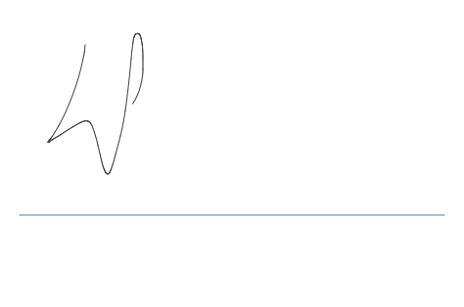

**NOTES**